Week-2
- Last week you wrote a program that printed out a cheery greeting including your name. Take a copy of it and modify it so that the user enters their name at the keyboard and then receives a greeting.
For example:
Hello, what is your name? Mr Apricot
Hello, Mr Apricot. Good to meet you!

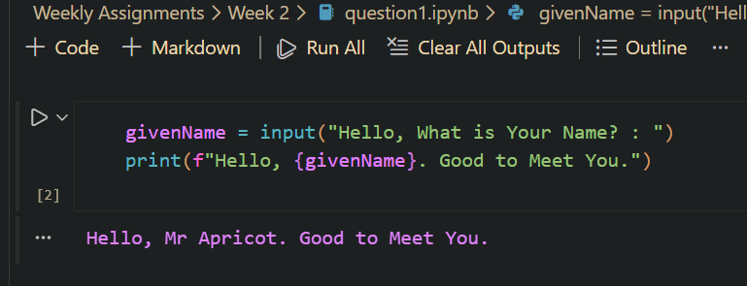

- Write a program that prompts a user to enter a temperature in Celsius, and then displays the corresponding temperature in Fahrenheit, like so:
Enter the temperature in Celsius: 32.5
32.5C is equivalent to 90.5F.

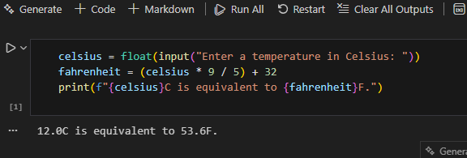

- The Head of Computing at the University of Poppleton is tasked with dividing a group of students into lab groups. A lab group is usually 24 students, but this is sometimes varied to create groups of similar size. Write a program that prompts for the number of students and group size and then displays how many groups will be needed and how many will be le over in a smaller group. How many students? 113 Required group size? 22 There will be 5 groups with 3 students left over. For bonus credit, see if you can fix the grammar in the output. So if there were 101 students in groups of 20 the output would be: There will be 5 groups with 1 student left over.
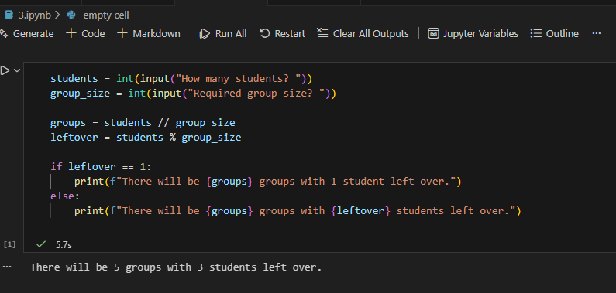

- A kindly teacher wishes to distribute a tub of sweets between her pupils. She will first count the sweets and then divide them according to how many pupils attend that day. Write a program that will tell the teacher how many sweets to give to each pupil, and how many she will have le over.

